Test Running
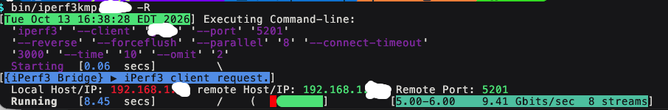
Test Complete
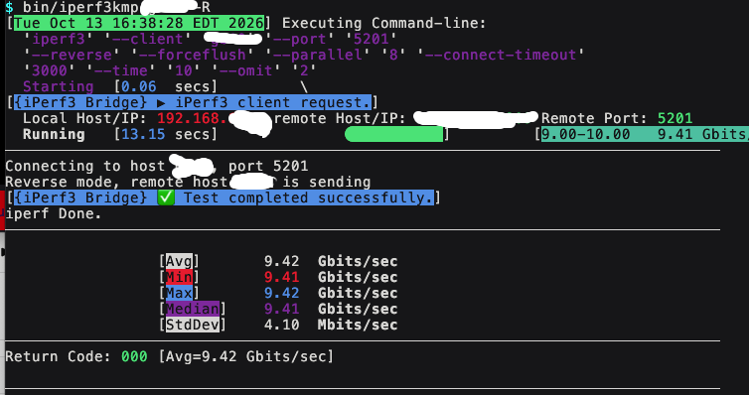

Kjllk

